

Discovery V2.0

Concept presentation

**Authors:**

**Jean-Jacques Chanut**, Mechanical engineer Sesame

**Issue date**: 01/22/2020

Contents

1. Revision History 3

2. Scope 4

3. Overview 4

4. Sub-assemblies 6

A. Sub-assembly details 7

a. Discovery chassis 8

b. Mini cubby 11

c. Power board bloc 11

d. Server supports 12

e. Switch support 13

f. Cables kit 13

g. Final parts 14

B. Assembly sequence 16

C. Sub-assemblies fastening parts 16

5. Assembly process 16

A. Phase 1 17

a. Discovery chassis assembly 17

b. Mini Cubby assembly 23

c. Power board bloc assembly 25

d. Switch assembly 26

B. Phase 2 27

C. Phase 3 30

D. Phase 4 31

E. Phase 5 32

# Revision History

|  |  |  |
| --- | --- | --- |
| Date | Name | Description |
| 01/22/2020 | JJ Chanut | Creation |
|  |  |  |
|  |  |  |
|  |  |  |
|  |  |  |
|  |  |  |

# Scope

This document describes 2 different concepts in order to integrate a 100Gbps switch in a discovery.

# Discovery V1 Overview

Discovery is a fully integrated mini mobile rack compatible with OCP Openrack V1 and V2 servers. This rack supports 5 slots 2 Open U and is powered by a standard electrical outlet (110-230v 16A).

Figure 1 & 2 Discovery rack

Discovery rack is divided into three zones as shown in Figure 3: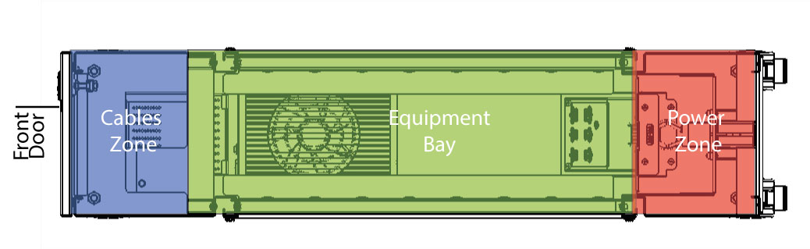Figure 3

* A Cable zone in front
* An Equipment Bay in the middle for all the equipment
* A Power zone on at the back

The Cable zone, located at the front of the rack, manages and protects the data cables connected to the IT equipment.

During installation, the equipment slides past the cable zone and rests on a series of horizontal supports within the rack. Once on the support, a DC connector in the equipment blind-mates into the bus bars in the Power zone.

The Power zone in the rack consists of a pair of bus bars that transmit power from a rack level power shelf to the equipment. The vertical bus bars connect the equipment with the PSU located below the Equipment Bay. The system is designed so that equipment in the Equipment Bay can attach to the bus bar continuously along its entire length to accommodate chassis of different sizes over multiple generations.

The discovery has 5x2 openU slots to integrate 4 servers and a network switch.

Figure 4 Front view of discovery chassis

# Sub-assemblies

The chassis is an assembly of interlocking sub-assemblies designed to be individually mounted to the rack.

Discovery rack is composed of 6 sub-assemblies:

|  |  |
| --- | --- |
|  |  |
|  |  |
|  |  |
|  |  |
|  |  |
|  |  |
|  |  |
|  |  |

## Sub-assembly details

The following section describes the composition of each sub-assembly.

### Discovery chassis

|  |  |  |
| --- | --- | --- |
| Part | Picture | Quantity |
| Weldment structure |  | 1 |
| Front door |  | 1 |
| Busbar |  | 1 |
| Front wheel |  | 2 |
| Back wheel |  | 2 |
| PSU support |  | 1 |
| Power board support |  | 1 |
| Server lock support |  | 4 |
| PSU |  | 1 |
| Foam pad |  | 2 |
| PSon connector |  | 1 |
| PSU screw |  | 4 |
| Busbar screw |  | 1 |
| Self-tapping Pan head screw M4x6 |  | 8 |

### Mini cubby

|  |  |  |
| --- | --- | --- |
| Part | Picture | Quantity |
| Mini cubby chassis |  | 1 |
| Mini cubby connector support |  | 1 |
| 1 head Medusa cable |  | 1 |
| Pan head screw M4x6 |  | 4 |
| Self-tapping pan head screw for plastic m3x15 |  | 2 |
| Washer M3 |  | 2 |
| Shoulder screw |  | 2 |

### Power board bloc

|  |  |  |
| --- | --- | --- |
| Part | Picture | Quantity |
| Power board |  | 1 |
| Studs |  | 4 |
| Power bar left |  | 1 |
| Power bar right |  | 1 |
| Hex nut M5 |  | 4 |

### Server supports

|  |  |  |
| --- | --- | --- |
| Part | Picture | Quantity |
| Server support left |  | 5 |
| Server support right |  | 5 |

### Switch support

|  |  |  |
| --- | --- | --- |
| Part | Picture | Quantity |
| Switch support chassis |  | 1 |
| Switch CRS305-1G-4S+IN |  | 1 |
| Switch screw |  | 1 |
| Pan head M4x5 |  | 1 |

### Cables kit

|  |  |  |
| --- | --- | --- |
| Part | Picture | Quantity |
| CPU 12V cable |  | 2 |
| Pcie cable | Afficher l’image source | 4 |
| PSon connector |  | 1 |
| Switch power cable |  | 1 |
| PSU power cord US |  | 1 |
| PSU power cord EU |  | 1 |

### Final parts

|  |  |  |
| --- | --- | --- |
| Part | Picture | Quantity |
| Busbar lug cover |  | 1 |
| Power board cap |  | 1 |
| Side wall |  | 2 |
| Back panel |  | 1 |
| Lug cover screw |  | 1 |
| Pan head M6x8 |  | 8 |
| Pan head M4x5 |  | 4 |
| Pan head screws M4x8 |  | 6 |

## Assembly sequence

There are 4 stages of assembly, the following table describes the assembly order of the different sub-assemblies.

Discovery chassis, Mini cubby, power board bloc and switch assembly can be assembled simultaneously.

## Sub-assemblies fastening parts

The following section list the fastening parts used for assembling the sub-assembly together.

Power board screws: 4x pan head M4x5

Busbar screws: X4 (Connect the

Mini cubby/server supports/switch supports/ server locker: x30 M5x8

# Assembly process

The following section describes the 5 phases to assemble a Discovery rack.

|  |  |
| --- | --- |
| Phase # | Sub-assembly concerned |
| 1 | Discovery chassis  Mini cubby  Power board bloc  Switch assembly |
| 2 | Assembly |
| 3 | Cable kit |
| 4 | Server support |
| 5 | Final parts |

## Phase 1

### Discovery chassis assembly

#### Step 1: mount the wheels

* x4 Hex nut M10
* X2 lockable Wheels
* X2 Wheels

Tighten the threaded rods of the wheels in the weldment structure of the discovery thanks to the M10 nuts, Lockable casters are located at the front of the chassis, the others at the back (Figure 5)

figure 5

#### Step 2: connect the PSon connector to the ATX plug of the PSU

* PSU
* PSon connector

PSon connector is plugged in as described in figure 6

Figure 6

#### Step 3: mount the power supply in its support

* x4 PSU screws
* PSU

Screw the PSU to the PSU support following figure 7-Torque: 4 to 7 ft-lb

Figure 7

#### Step 4: Mount the PSU support on the discovery weldment structure

* x4 M4x6 self-taping pan head screws
* assembly PSU support + PSU

Screw the PSU support on the discovery weldment structure (figure 8) -Torque: 4 to 7 ft-lb

Figure 8

#### Step 5: mount the Power board support

* x4 M4x6 self-taping pan head screws
* power board support

Screw the power board support on the discovery weldment structure (figure 9) -Torque: 4 to 7 ft-lb

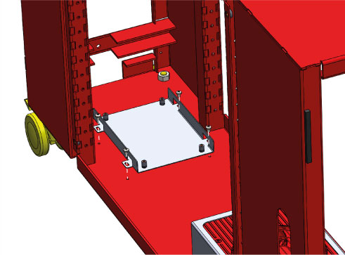  
Figure 9

#### Step 6: mount the Busbar

* Bus bar
* Bus bar screw

Install the bus bar inside the discovery structure in the reserved location (figure 10).

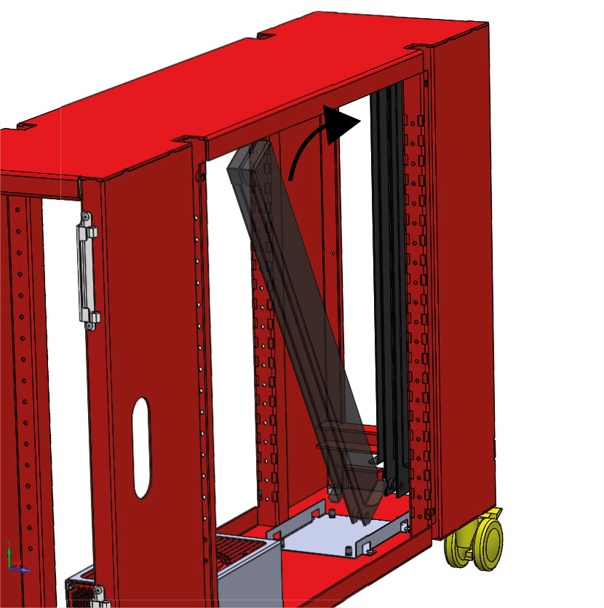  
Figure 10

Screw the busbar at the Discovery structure (figure 11) -Torque: 4 to 7 ft-lb

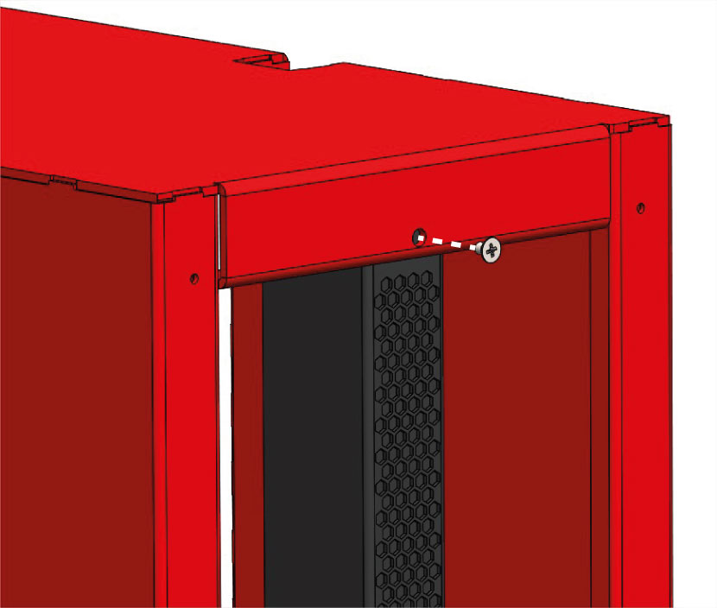  
Figure 11

#### Step 7: mount the server lockers

* X4 server lockers
* X8 pan head self-tapping M5x6

Screw the server lockers as described in figure 12-Torque: 7 to 8 ft-lb

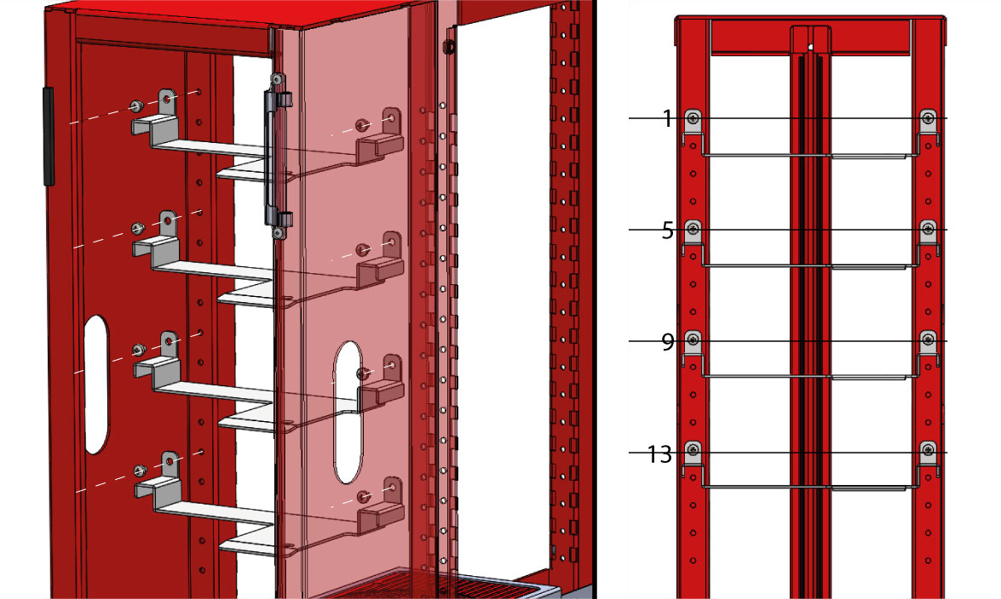  
Figure 12

#### Step 8: mount the front Door

Assemble the front door to the discovery structure (figure 13)

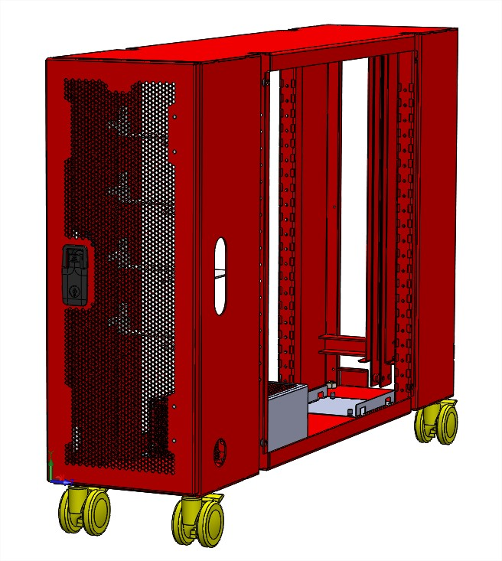  
Figure 13

#### Step 9: Assemble the Foam pads

* X2 Foam pads

Remove the protective film in the foam pads (figure 14)

Figure 14

Assemble the pads as described on figure 15

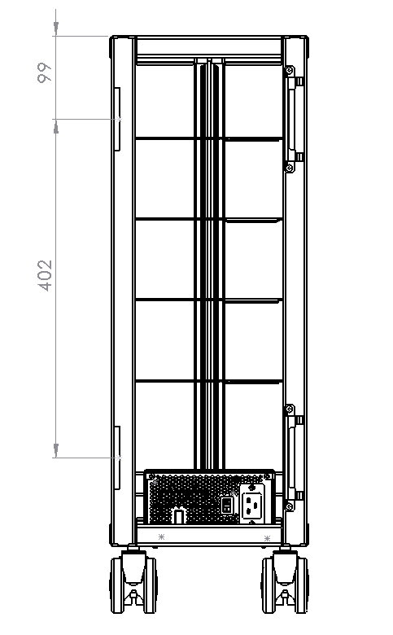  
Figure 15

#### Step 10: Set up the locker

### Mini Cubby assembly

#### Step 1: mount the medusa cable within the connector support

* X2 shoulder screws
* Connector support

Medusa cable is composed of a server-side connector and a bus bar side connector (figure 16)

Figure 16

Screw the medusa cable server-side connector to the connector support (figure 17)  
-Torque: 4 to 7 ft-lb

Figure 17

#### Step 2: Screw the connector support to the Mini Cubby chassis

* X4 Pan head screw M4x6
* Assembly medusa cable/ connector support

Screw the connector support to the mini cubby chassis (figure 18) -Torque: 4 to 7 ft-lb

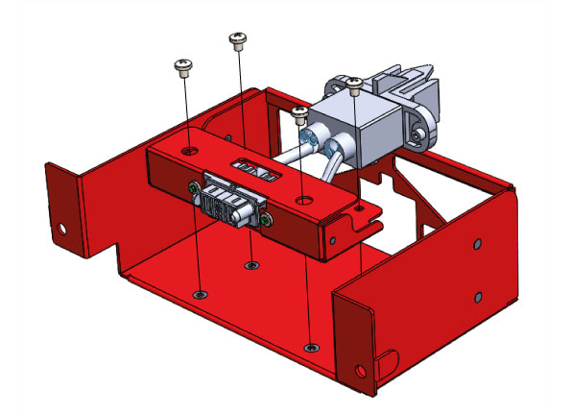  
Figure 18

#### Step 3: Screw the medusa cable to the Mini Cubby chassis

* X2 Self-tapping pan head screws for plastic m3x15
* X2 washers M3

Screw the BUS bar side connector to the mini Cubby chassis as described on figure 19  
-Torque: 4 to 7 ft-lb

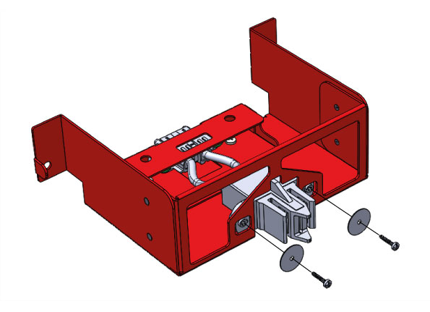  
Figure 19

### Power board bloc assembly

* Power bar left
* Power bar right
* X4 nuts M5
* X4 threaded studs
* Power board

Position the 4 threaded studs in the corresponding holes of the power board.  
Stack the left and right power bars and tight them with the 4 M5 nuts (figure 20).

Figure 20

The threaded studs will be crimped to the power board thanks to the tightening (figure 21)

Figure 21

### Switch assembly

* Mikrotik switch
* Switch support
* X1 Switch screw
* X1 Pan head M4x5

Screw the switch in its support as described in figure 22. -Torque: 6 to 7 ft-lb

Figure 22

## Phase 2

#### Step 1: mount the power board bloc within the chassis

* x4 M4x5 pan head screws
* Power board bloc
* X4 power bar screw

Stack the power board cap and the power board bloc, then screw them in the discovery structure as described in figure 23 -Torque: 6 to 7 ft-lb

Figure 23

#### Step 2: mount the Mini Cubby within the chassis

* X2 Self tapping Pan head M5X6 screws
* X 4 Mini cubby

Screw the Mini Cubby in the discovery structure as described in figure 24-Torque: 7 to 8 ft-lb

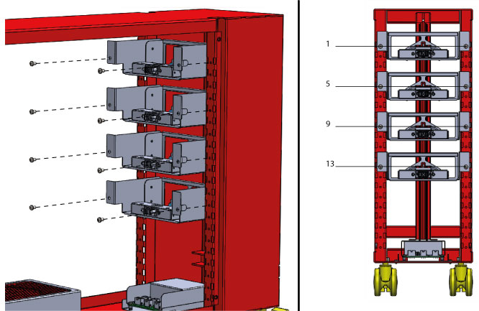  
Figure 24

#### Step 3: mount the Switch assembly within the chassis

* X2 Self tapping Pan head M5X6 screws
* Switch assembly

Screw the switch assembly in the discovery structure as described in figure 25. -Torque: 7 to 8 ft-lb

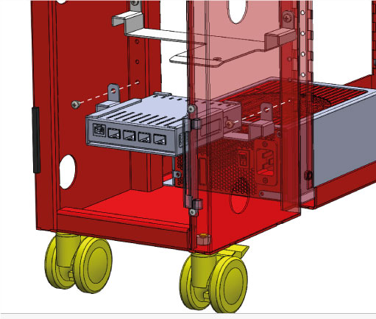  
Figure 25

## Phase 3

This section describes cables connections between the power board, the PSU and the network switch.

The power board have 2x8 pins connectors, 4x6 pins connectors and a 2 pins connector as describe on figure 26.

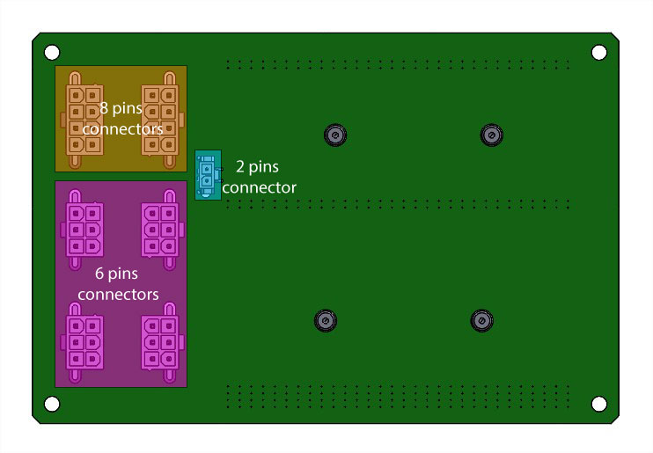  
Figure 26

#### Step 1: 12V CPU cable

Connect the 2x12V cables from the PSU to the 8 pins connector of the power board (fig.27)

Figure 27

#### Step 2: Pcie Cable

Connect the 4xPCIe cables from the PSU to the 8 pins connector of the power board (fig.28)

Figure 28

#### Step 3: Switch power cable

Connect the switch power cable from the power board to the switch on DC1 connector (fig.29).

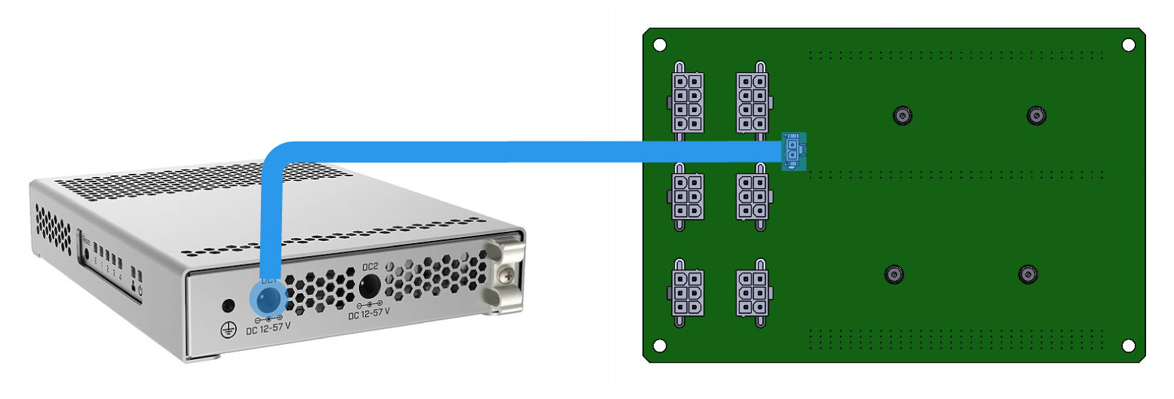  
Figure 29

## Phase 4

#### Mount the server supports

* X5 server supports left
* X5 server supports right
* X 10 Self tapping Pan head M5X6 screws

Screw the server supports as describes in fig. 30. -Torque: 7 to 8 ft-lb

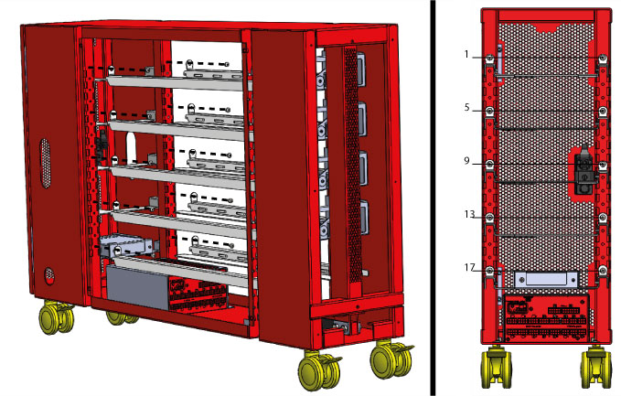  
Figure 30

.

## Phase 5

#### Step 1: mount the busbar lug cover

* X1 lug cover screw
* Bus bar lug cover

Screw the bus bar lug cover as describes in fig. 31. -Torque: 4 to 7 ft-lb

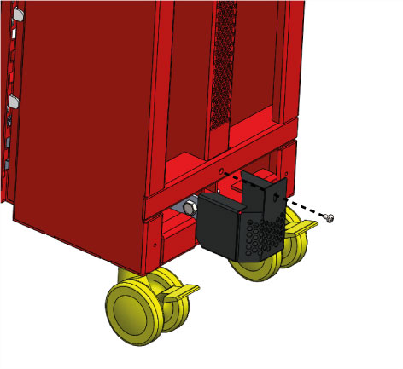  
Figure 31

#### Step 2: mount the back panel

* X4 Pan head screws M4x8
* Back panel

Screw the back panel as describes in fig. 32. -Torque: 4 to 7 ft-lb

Figure 32

#### Step 3: mount the side panels

* X8 screws M6x8

X2 side panelsScrew the side panels as describes in fig. 33. -Torque: 7 to 8 ft-lb

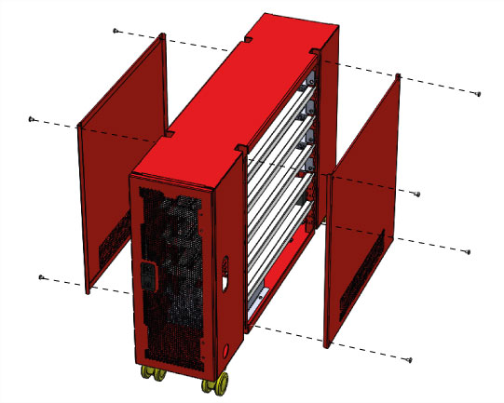  
Figure 33